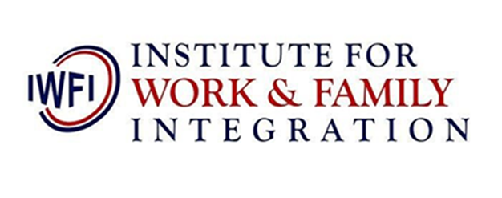

N10,000 per person

N15,000 per couple.

Online Course

5th and 6th June 2020.

**MARRIAGE RELATIONSHIP PROGRAMME**

Register and pay here…